WEEK 1

**Week1**

**Video-1) Introduction**

-Learnt two types of AI

1). ANI – Artificial Narrow intelligence eg. Speech recognition, smart ai speakers, alexa etc….

2) AGI – Artificial General Intelligence = The AI which can do all the work that Human can do.

**Video-2) Machine Learning**

* Learnt Supervised Learning Model which works on Input 🡪 Output
* A🡪B here A is Input and B is Output
* Graph of certain AI sub Domains , at one point of time the graph does not accelerate exponentially but goes in parallel with increase in amount of DATA.

**Video-3) What is DATA?**

* There are two types of Data:

1) Structured Data – MS excel sheet, Data Sheet

2) Unstructured Data – Images, audio, text

Saw an example where data is whether structured or un-structured.

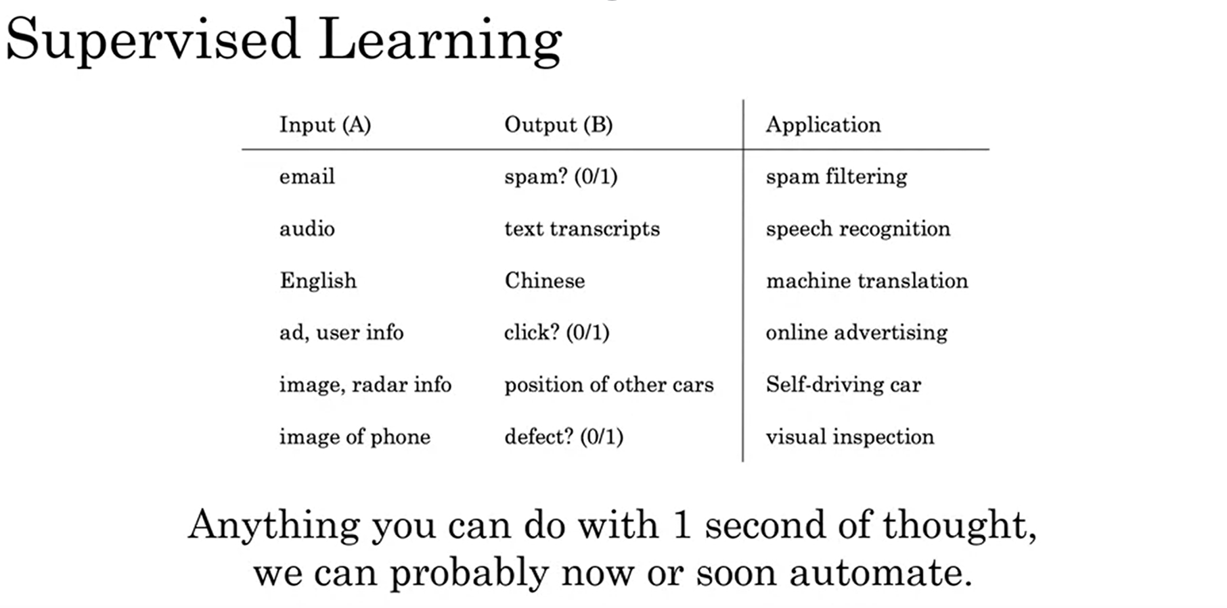

**Video-4) The terminologies of AI?**

Terminologies like Data Science, Machine Learning and Deep learning as well as Neural Networks.

Neural Networks works with connecting neurons to each other and it is the intermediate process for input A and output B.

**Video-5) What makes an AI company?**

Not required first earn then build company

**Video-6) What ML can and cannot do?**

Examples of What AI can or cannot do?  
Its obvious from observation till now that you need a large amount of data, simply 4k-5k data values cannot make your AI system perform well however here we are assuming from the perspective of a company to answer email address/ query addressable system. And to make your AI stable not just you require input A, you also need out B to make ML understand that if this is the case where input is A then formal output will be B.

**Video-7) More Examples of What ML can and cannot do?**

Few examples of self-driving car using ML to drive and medical doctor identifying Pneumonia from few X-ray images whereas AI needs tons of images with labelled to identify whether pneumonia can be identified or not. So this is the example of what AI cannot do. Similarly self-driving can cannot identify the gesture of a person showing hand to show the intension to turn left.